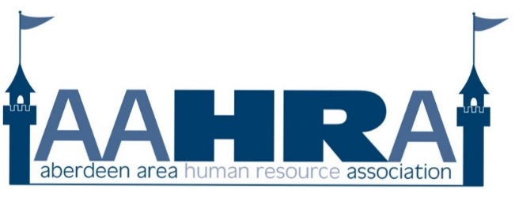
Kim Bowman, President
Jillaine Naasz, President- Elect
Jen Weber, Secretary/Treasurer
P.O. Box 79
Aberdeen, SD 57402-0079
605-725-8349 – Kristin Kroell
http://aahra.shrm.org

Date: Thursday, December 21, 2017 12:00 p.m.

Location: Max and Erma’s

Attendees: Jen Weber, Sheila Sutton, Emily Hoekman, Kristi Bockorny, Laura Millett, Tammy Spellman, Donna Hurley, Dean Karlen, Kristen Kroell, Jodi Myburgh, Kim Bowman

Agenda: Chapter Christmas Party

Old Business:
- Bylaw Approval- Voted and approved bylaws, mission and vision statement.

New Business:
- Enjoyed the Christmas party and gift card exchange.

